|  |  |  |  |  |  |  |  |  |  |  |  |  |
| --- | --- | --- | --- | --- | --- | --- | --- | --- | --- | --- | --- | --- |
| |  |  | | --- | --- | | **Semester Two Examination 2016** | ccc-logo | | **Question/Answer Booklet** |   **PHYSICS**  **12 ATAR**   |  |  |  | | --- | --- | --- | | Student  Number: | In  Figures |  | |  | In words |  | |  |  |  | |

**Time allowed for this paper**

Reading time before commencing work: Ten minutes

Working time for paper: Three hours

**Materials required/recommended for this paper**

***To be provided by the supervisor***

This Question/Answer Booklet/Formulae and Data Booklet

***To be provided by the candidate***

Standard items: pens (blue/black preferred), pencils (including coloured), sharpener, correction tape/fluid, eraser, ruler and highlighters

Special items: non-programmable calculators approved for use in this examination, drawing templates, drawing compass and a protractor

**Important note to candidates**

No other items may be taken into the examination room. It is **your** responsibility to ensure that you do not have any unauthorised material. If you have any unauthorised material with you, hand it to the supervisor **before** reading any further.

**Structure of this paper**

|  |  |  |  |  |  |
| --- | --- | --- | --- | --- | --- |
| Section | Number of questions available | Number of questions to be answered | Suggested working time (minutes) | Marks available | Percentage of exam |
| Section One: Short answers | 14 | 14 | 50 | 54 | 30 |
| Section Two: Problem-solving | 7 | 7 | 90 | 90 | 50 |
| Section Three: Comprehension | 16 | 16 | 40 | 36 | 20 |
|  |  |  |  | Total | 100 |

**Instructions to candidates**

1. The rules for the conduct of the Western Australian Certificate of Education ATAR course examinations are detailed in the *Year 12 Information Handbook 2016*. Sitting this examination implies that you agree to abide by these rules.
2. Write your answers in this Question/Answer booklet.
3. When calculating or estimating answers, show all your working clearly. Your working should be in sufficient detail to allow your answers to be checked readily and for marks to be awarded for reasoning.

In calculations, give final answers to three significant figures and include appropriate units where applicable.

In estimates, give final answers to a maximum of two significant figures and include appropriate units where applicable.

1. You must be careful to con ne your answers to the specific questions asked and to follow any instructions that are specific to a particular question.
2. Additional working space pages at the end of this Question/Answer booklet are for planning or continuing an answer. If you use these pages, indicate at the original answer, the page number it is planned/continued on and write the question number being planned/continued on the additional working space page.
3. The Formulae and Data booklet is not to be handed in with your Question/Answer booklet.

**Additional Data**

|  |
| --- |
|  |
|  |
|  |

**Section One. Short responses. 30% (54 Marks)**

Attempt **ALL FOURTEEN** (14) questions in this section. Marks for each question are clearly identified.

**­­­­­­­­­________________________________________________________________**

|  |  |
| --- | --- |
| **1.** The distance between the proton and the electron in the ground state of the hydrogen atom is defined as the Bohr radius. Given that the Bohr radius can be measured as r = 5.29 x 10-11 metres, what is the force experienced by the electron as it orbits in the atom? **[4 marks]** |  |

|  |  |
| --- | --- |
| **2.** Consider the decay equation shown here showing hadron interactions. Show that charge, baryon number and strangeness are all conserved. **[3 marks]** |  |

|  |  |
| --- | --- |
| Charge |  |
| Baryon number |  |
| Strangeness |  |

|  |  |
| --- | --- |
| **3.** A football is kicked horizontally from the edge of a cliff into a river below with a speed of 10 ms-1, as shown here. Calculate the **velocity** with which the ball enters the water. **[5 marks]** |  |

**4.** Find the De Broglie wavelength, **in nm**, of an electron of rest mass 0.511 MeV, traveling at a velocity of 3.00 x 10-5 ms-1. **[2 marks]**

**5.** A light source of wavelength 45.0 nm strikes a metal whose work function is 4.0 eV.

1. What is the maximum kinetic energy of the emitted photoelectrons? **[3 marks]**
2. The intensity of the light being used is doubled. How will this affect the numbers of photoelectrons emitted, the photocurrent produced and the energy of the kinetic energy photoelectrons emitted? **[3 marks]**

|  |  |
| --- | --- |
| Number of photoelectrons |  |
|  |
| Photocurrent |  |
|  |
| Kinetic energy |  |
|  |

|  |  |
| --- | --- |
| **6.** In 2012, the Hot-Wheels toy company executed a car stunt where a typical family car successfully performed an inverted loop on a specially designed, 6-storey loop.  At the top of the loop, the car is just in contact with the road. **Estimate** the minimum velocity, *v*, required to keep the car in contact with the road at this point. **[4 marks]** |  |

**7.** Two current carrying conductors are shown in the diagram below.

1. Sketch the resultant magnetic field and clearly label any areas of high or low flux density. **[2 marks]**

here is a force of repulsionng at 5x105 ms-1quired to keep a proton corculating here is a force of repulsionng at 5x105 ms-1quired to keep a proton corculating here is a force of repulsionng at 5x105 ms-1quired to keep a proton corculating

|  |  |  |
| --- | --- | --- |
|  |  |  |

1. Is there any force between the two conductors? Circle the correct answer below. **[1 mark]**

here is a force of repulsionng at 5x105 ms-1quired to keep a proton corculating **here is a force of repulsionng at 5x105 ms-1quired to keep a proton corculating**

|  |  |  |
| --- | --- | --- |
| *There is a force of repulsion* | *There is no force* | *There is a force of attraction* |

**8.** The large hadron collider (LHC) is a particle collider located on the Swiss/French border. A large magnetic field, created using superconducting solenoids, keeps hadrons circling around a 27 kilometre circumference at speeds approaching the speed of light. Calculate the magnetic field strength required to keep a proton circulating inside the solenoids- traveling at 5 x10 5 ms-1. **[4 marks]**

**9.** Consider the classification table (below) for elementary particles. Write the missing headings in the spaces provided. **[2 marks]**

|  |
| --- |
|  |

**10.** The visible part of the solar spectrum shows numerous thin dark lines appearing on the continuous spectrum as shown here:

|  |
| --- |
|  |

Explain what these lines are and how they are produced. **[3 marks]**

|  |
| --- |
|  |
|  |
|  |
|  |

|  |  |
| --- | --- |
| **11.** The diagram shows the typical human visual response for a green laser pointer (GLP). The wavelength of the GLP line is at 532 nm and the 650 nm wavelength of a typical red laser pointer is shown. Given that the GLP operates with a power of 110 W, calculate the number of photons emitted in 10 seconds. **[4 marks]** |  |

**12.** A pion is a subatomic particle consisting of a quark and an antiquark. What is the speed of a pion if its average lifetime is measured to be 4.10 x 10-8 seconds? At rest, its average lifetime is 2.60 x 10-8 seconds. **[5 marks]**

|  |  |  |
| --- | --- | --- |
| **13.** The 355 nm spectral line of an element is found to be 366 nm in the light coming from the galaxy shown here.   1. Is this a red shift, or a blue shift? **[1 mark]**  |  | | --- | |  | |  |

1. Is the galaxy receding, or moving towards us? **[1 mark]**

|  |
| --- |
|  |

1. Calculate the velocity of the galaxy. **[2 marks]**
2. Use a Hubble Constant of Ho = 71 kms-1Mpc-1 to determine the distance to the galaxy in light years. **[2 marks]**

|  |  |
| --- | --- |
| **14.** An armature of an AC generator rotates in a field of strength 0.20 T. The area of the armature is 5.0 x 10-2 m2. As the coil rotates from the vertical to the horizontal in 20 ms, the maximum voltage required is 150 volts. How many loops should the coil contain to achieve this? **[3 marks]** |  |

**Section Two. Problem solving. 50% (90 Marks)**

Attempt **ALL SEVEN** (7) questions in this section. Marks for each question are clearly identified.

**­­­­­­­­­**

**15.** Tom is caught on a banked roundabout in East Perth. He is travelling at a steady speed, and his situation is shown in the plan and side views below. The car’s speed is such that there is no sideways frictional force between the tyres and the road. **[14 marks]**

|  |  |  |  |  |  |  |
| --- | --- | --- | --- | --- | --- | --- |
| 1. Does Tom's car have an acceleration? Explain your answer. **[2 marks]**  |  | | --- | |  | |  | |  | |  | |  | |  |

|  |  |
| --- | --- |
| 1. We could represent Tom's car on the roundabout by a block in the diagram below. On the diagram above, draw and label all the forces acting on the moving car? **[3 marks]** |  |

1. Is there a resultant force acing on the car? Explain your answer. **[2 marks]**

|  |
| --- |
|  |
|  |
|  |
|  |

1. Why is it that engineers, when designing roundabouts and freeway off ramps, often bank them? Use a diagram to assist your answer. **[2 marks]**

|  |
| --- |
|  |
|  |
|  |
|  |

1. Using any necessary assumptions, calculate the speed that the car must travel at in order for there to be no sideways frictional force between the tyres and the road? **[3 marks]**
2. Suppose now that some oil had been spilled on the roundabout. What effect would this have on Tom's car if he maintained the speed you calculated in part (e)? Explain your answer. **[2 marks]**

|  |
| --- |
|  |
|  |
|  |
|  |
|  |
|  |

**16.** At the centre of the Milky Way is a black hole known as Sagittarius A*. It has a mass equivalent to 4.31 billion Suns. It is 26,500 light years from the Sun. A light year is the distance light would travel in one year. **[11 marks]**

1. Calculate the gravitational force between the black hole and the Sun. **[3 marks]**
2. Using this force (from part a), to calculate the orbital speed of the Sun around the black hole. **[3 marks]**
3. The Sun moves around the black hole (assume circular orbit) with a speed of

2.20 x 102 kms-1. Calculate the centripetal force involved in creating this orbit.

**[2 marks]**

1. Compare the values of part (b) and (c). Explain why they are different. **[3 marks]**

**17.** The Perth Wildcats basketball team is two points down and Damien Martin has the ball in centre court. He puts up the shot and scores three points. **[15 marks]**

|  |
| --- |
|  |

|  |  |
| --- | --- |
| 1. In the space here, draw a diagram of the ball showing the force/s acting on it whilst in flight. Assume no air resistance. **[2 marks]** |  |

1. Martin propels the ball at an angle to the horizontal of 42.5o. What is the initial speed of the ball as shown in the diagram? **[6 marks]**
2. Calculate the velocity as it passes through the ring in order to score the three points to win the game. **[7 marks]**

**18.** A simple crane is used in a service station to lift engines (represented as load L) from cars and transfer them to a workbench. Rollers are used so that the mechanic can move the engine from one end of the beam to the other as shown in the diagram. The beam (B) is 2.50 m long, the support wire (S) is attached 0.50 m from the outer end at an angle of 35.0° to the beam. **[11 marks]**

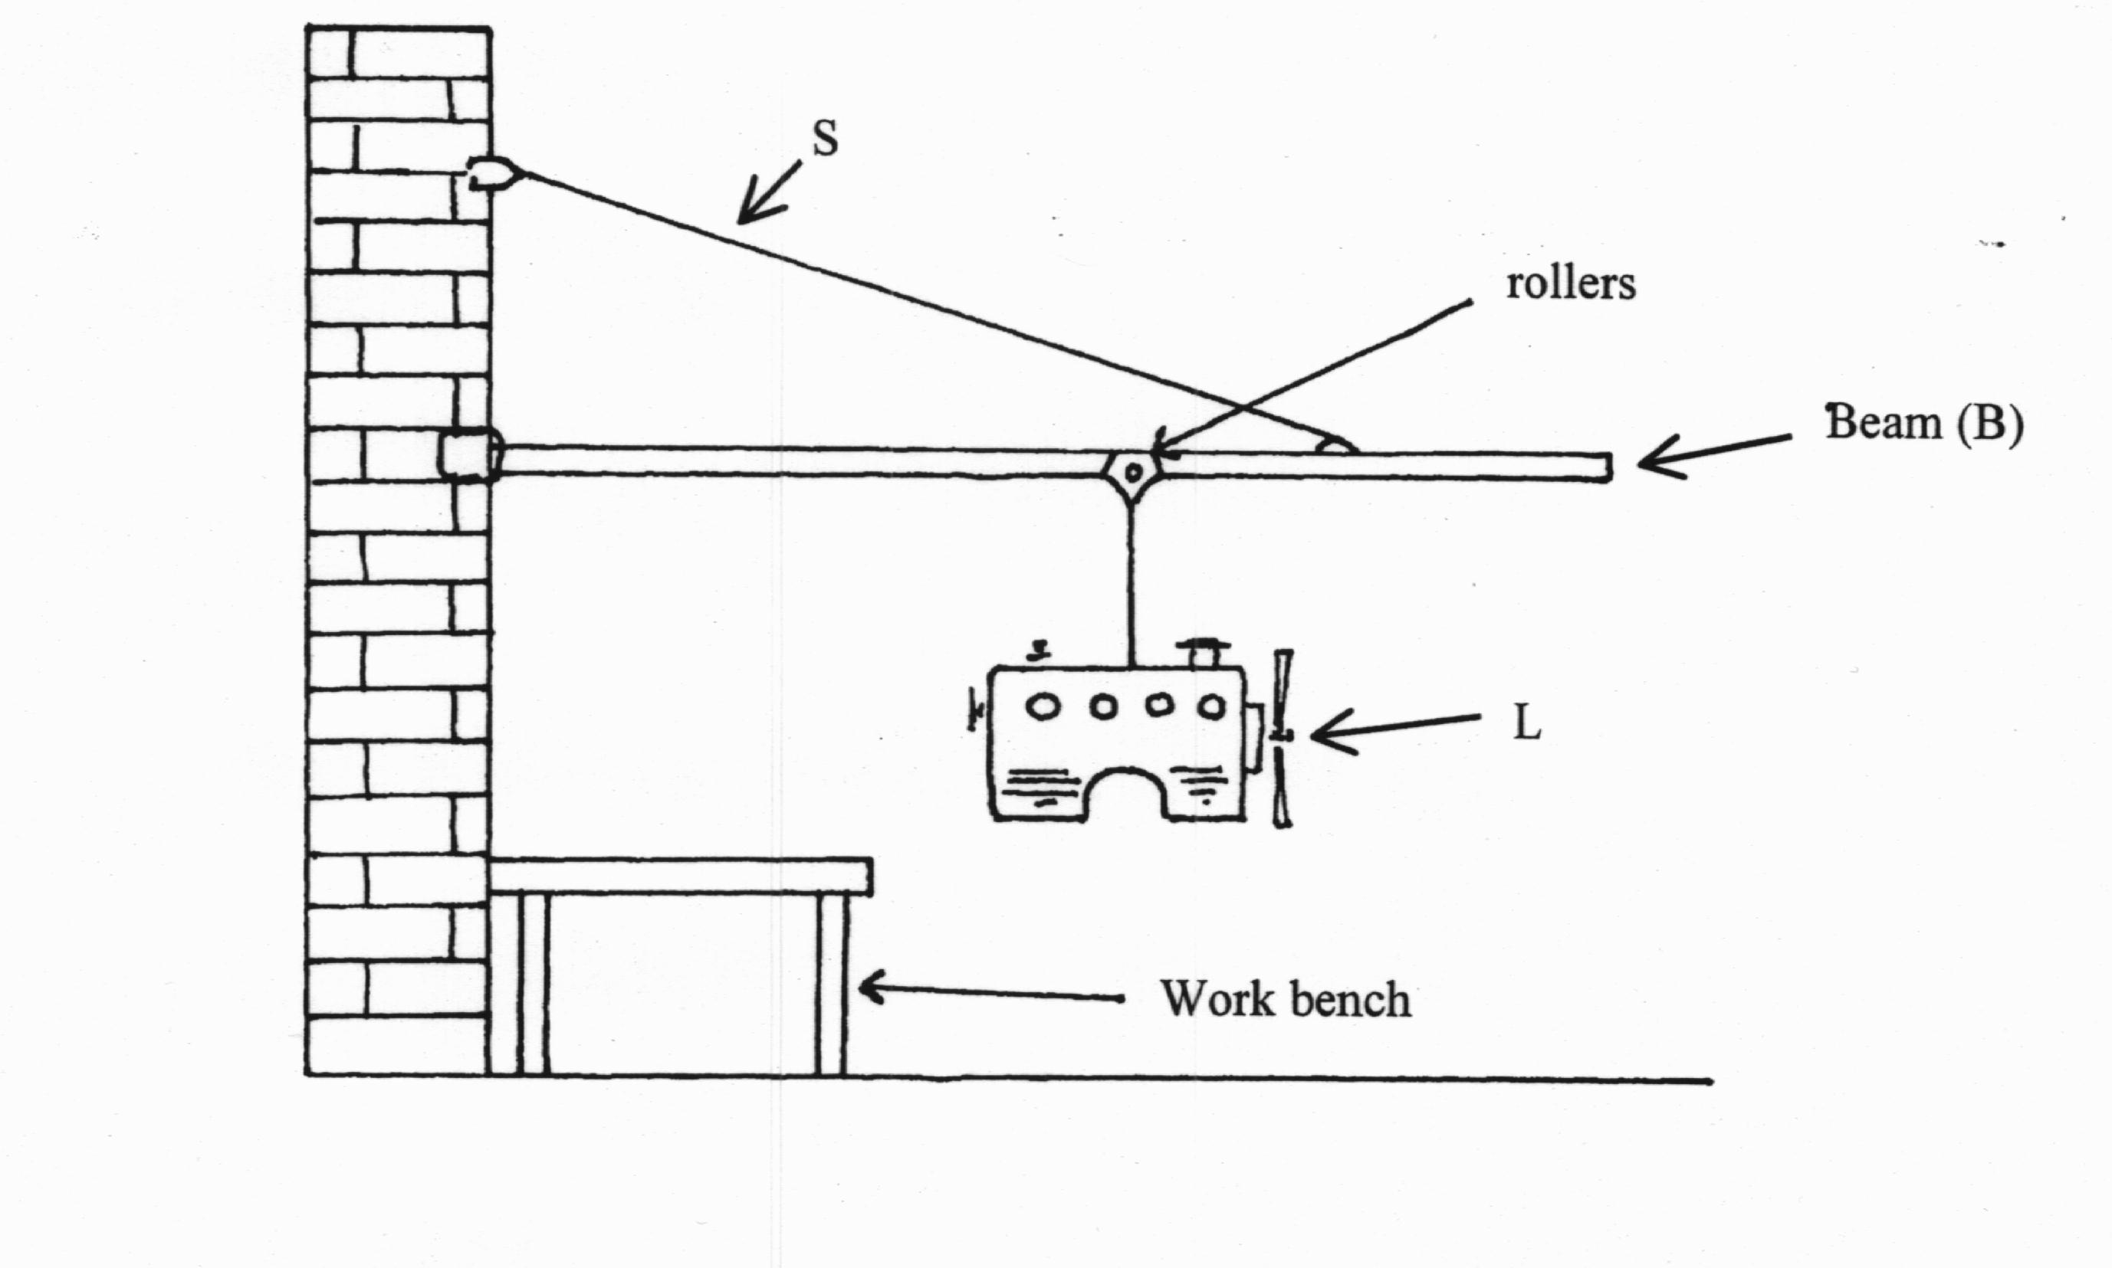

The beam is uniform and has a mass of 38.5 kg. The combined mass of the engine and the rollers is 165 kg. In the current position, the load is 1.50 m from the wall.

1. On the diagram above, draw all of the forces acting with the load in the position shown. **[3 marks]**
2. Find the tension in the support cable “S”, when the engine is at the position shown.

**[3 marks]**

1. Find the magnitude and direction of the reaction force that the wall exerts on the beam. **[5 marks]**

**19.** (a) A metal axle from a model railway train is propelled along two live rails as shown in the diagram below. **[14 marks]**

|  |
| --- |
|  |

1. For the axle to move in the direction shown, a magnetic field of intensity of

4.00 x 10-2 T is applied. ***Circle the direction/letter*** next to the arrow that indicates the direction of the magnetic field. **[2 marks]**

1. The axle has a mass of 55.0 g and has a length of 4.00 cm. Find its acceleration if the current through the axle is 16.0 A. **[3 marks]**
2. In fact, the acceleration is somewhat less than that calculated in part (ii). Suggest ***two*** reasons for this. **[2 marks]**

|  |
| --- |
|  |
|  |
|  |
|  |
|  |
|  |

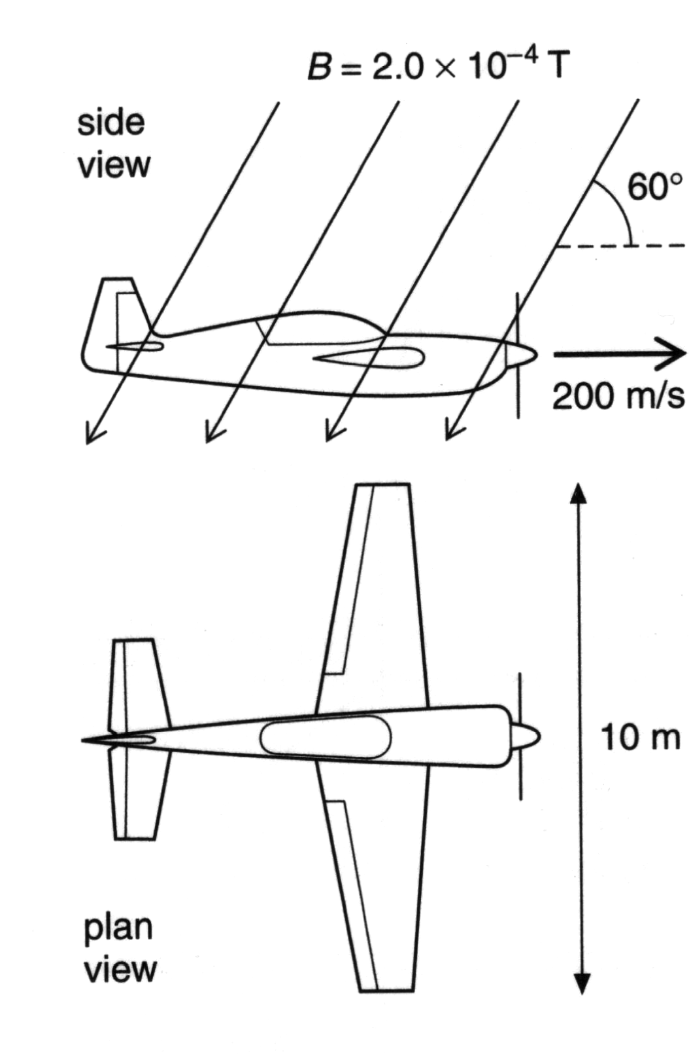(b) An aeroplane with a wingspan of 10.0 m is flying horizontally at a velocity of 2.00 x10 2 ms-1 due north in the southern hemisphere. In the region the plane is flying, the Earth’s magnetic field is 2.00 x 10-4 T at an angle of 60.0° to the horizontal.

(i) Which component (horizontal or vertical) of the Earth’s magnetic field is used to calculate EMF across the wings? **[1 mark]**

(ii) Find the size of this component of the field.

**[2 marks]**

(iii) Calculate the EMF is induced across the wingtips of the plane. **[2 marks]**

(iv) Could this EMF be used to power the cabin lights? Explain your answer.

**[2 marks]**

**20.** A mining company use an electric pump with an operating voltage in the range

1.25 kV-1.50 kV. There is only a 240 VRMS supply available. A transformer is used to step up the output voltage to 1.50 kVRMS. The secondary winding of the transformer has 2000 turns of wire. **[12 marks]**

|  |
| --- |
| Input  240 V  Output  1.50 kV  Electric Pump (Vd = 1.45 kV)  Cables  Transformer |

1. Calculate the number of turns required on the primary winding of the transformer. **[2 marks]**

The transformer has an electrical power output of 6.45 kW. The underground pump is connected by 1.10 km of cables to the surface. The potential difference across the pump is 1.45 kV.

1. Calculate the total resistance of the cables. **[4 marks]**
2. Calculate how much electrical energy per second is transformed to heat in the cables. **[2 marks]**
3. Describe two design features of a commercial transformer that increase its efficiency. **[2 marks]**
4. Explain why it is more efficient to transfer electricity to the pump at a high voltage of 1.50 kV rather than 240 V. **[2 marks]**

**21.** The diagram below details some of the energy levels for a metallic vapour that surrounds a star. **[13 marks]**

|  |
| --- |
|  |

1. Is it possible for this atom to absorb a 6.50 eV photon whilst in the ground state? Briefly explain your answer. **[1 mark]**

|  |
| --- |
|  |
|  |

1. Whilst in the ground state, the atom absorbs a 6.72 eV photon. How many lines in the emission spectrum would be possible as the atom de-excites? Indicate them on the diagram. **[1 mark]**

|  |  |  |  |
| --- | --- | --- | --- |
|  |  | Number of line = |  |

1. Calculate the longest wavelength possible in the emission spectrum when an atomic electron at E4 can de-excite by one or more steps to ground level.

**[3 marks]**

1. For the wavelength you calculated in part (c), state which area of the electromagnetic spectrum this belongs. **[1 mark]**

|  |
| --- |
|  |

A **single** atom in the ground state is bombarded by **one** electron with a kinetic energy of 6.10 eV.

1. Detail in the table below the possible photon energies observable on de-excitation and the possible bombarding electron energies after its interactions with the atom. **[3 marks]**

|  |  |
| --- | --- |
| Possible photon energies on de-excitation (eV) | Possible bombarding electron energy after interaction with the atom (eV) |
|  |  |

1. Explain briefly how analysis of a line absorption spectrum of light from distant galaxies can be used to determine the composition of stars and gas clouds.

**[2 marks]**

|  |
| --- |
|  |
|  |

1. The line absorption spectrum is also useful to determine the speed of a galaxy. Explain the fundamental principles of this technique. **[2 marks]**

|  |
| --- |
|  |
|  |

**Section Three. Comprehension. 20% (36 Marks)**

There are **two** pieces of reading. Attempt **ALL SIXTEEN** (16) questions in this comprehension section. Marks for each question are clearly identified.

**­­­­­­­­­**

|  |  |
| --- | --- |
| **Reading One:** | **The Physics of Skipping Stones** |

(Adapted from: The Mystery of the Skipping Stone, Physics World Vol 19 No 2 February 2006 Bocquet L and Clanet C)

|  |  |
| --- | --- |
| http://discovermagazine.com/~/media/import/images/5/1/4/featscience1 | Champion stone skipper Kurt Steiner has been stopped going through customs with bags full of rocks and always carries a five-sided stone in his pocket. |

In 2002 an American named Kurt Steiner set a new world record when he threw a

stone across a river in Pennsylvania and made it bounce 40 times. Most people will

not have been quite as successful as Steiner, but many will be familiar with the

principle of stone skipping: to throw a flattish stone across the surface of a body of

water so that it bounces as many times as possible.

It has been shown that the formula that relates collision time (of a stone with the water

surface) and velocity for a stone is given by;

|  |  |  |
| --- | --- | --- |
|  |  |  |

|  |  |  |  |
| --- | --- | --- | --- |
|  | where: | T is the collision time (s)  M is the mass of the stone (kg)  R is the radius of the stone (m)  is the density of water (kgm-3)  S is the cross sectional area of the stone (m2)  v is the velocity of the stone (ms-1) |  |

The data below pertains to a stone of dimensions:

= 15 g; = 3 cm; = 3.6 x 10-6 m2

|  |  |  |
| --- | --- | --- |
| **Collision Time (ms)** | **Velocity (ms-1)** |  |
| 56 | 2 |  |
| 37 | 3 |  |
| 22 | 5 |  |
| 16 | 7 |  |
| 12 | 9 |  |
| 10 | 11 |  |
| 7.5 | 15 |  |

1. Given the formula on the previous page, what should you plot to obtain a linear graph? **[2 marks]**

|  |
| --- |
|  |
|  |

1. Use the third column in the table to process the given data to allow you to plot a linear graph. Label the column with appropriate units. **[3 marks]**

1. Plot the graph on the graph paper provided on the next page. **[5 marks]**
2. Determine the gradient of your line. **[2 marks]**

|  |
| --- |
|  |

1. Use the gradient of your curve to determine the density of water. **[2 marks]**

Experiments have also shown that a bouncing stone must spin with a certain minimum rotational velocity if it is to be stable i.e. if the angle between the plane of the stone and the water surface is to remain constant. To remain stable, a stone typically needs to rotate at least once during its collision time. If this rotation does not take place, the stone’s collision becomes quite complex and a second bounce becomes much less likely.

1. If a stone is to rotate at least once during its collision time, what is the minimum spin velocity required? (Hint – this does not require a numerical answer) **[1 mark]**

|  |
| --- |
|  |

1. People who are good at stone skipping, intuitively rotate stones with a flick from the finger. Why do they do this? **[1 mark]**

|  |
| --- |
|  |

Researchers found that, surprisingly, the stone does not slow down during the skipping process, but rather the stone’s trajectory ‘flattens’ with time. This is because the angle with which the stone moves relative to the water dictates that the stone displaces more water when it moves down than rises. This results in a smaller transfer of momentum in the latter stage of each skip and therefore in reduced lift. When the stone no longer has enough energy to jump, it simply surfs over the water before finally sinking.

The number of skips is also determined by the type of stone used and the angle at which it is thrown. And as all stone skippers know, the flatter the stone, the better!

1. The passage describes the stone’s trajectory as ‘flattening’. Explain what this means with regards to changes in the horizontal and vertical components of the velocity. **[1 mark]**

|  |
| --- |
|  |

1. Why would there be reduced lift in the latter stages of the motion? **[1 mark]**

|  |
| --- |
|  |

|  |  |
| --- | --- |
| **Question Two** | **Gravitational Red Shift** |

Red shift is often explained as being similar to the Doppler Effect. An example of the Doppler Effect is the alteration in sound that occurs when a car passes. As the car approaches the observer the sound of the engine is higher than after the car has passed.

Cosmological Red shift and Blue shift occurs in a similar way. Instead of sound being emitted by a car moving towards or away from you however, it is light being emitted by a star as it moves towards or away from the earth. If the star is moving towards the Earth, all of the frequencies emitted will be slightly increased. This is called Blue shift. Conversely, if the star is moving away from the earth all of the frequencies emitted will be slightly lowered. This is called Red shift.

|  |  |
| --- | --- |
| The formula for cosmological red-shift is: | fL = ( ) fS |

Where:

|  |  |  |
| --- | --- | --- |
| **Symbol** | **Definition** | **Units** |
| fL | Frequency observed by the person on earth. | Hz |
| fS | Frequency of the source | Hz |
| c | Speed of light in a vacuum (3 x 108 m s-1) | m s-1 |
| v | Speed of the object producing the electromagnetic radiation (light)  v = away from earth 🡪 v = positive.  v = towards the earth 🡪 v = negative. | m s-1 |

Instead of considering blue and red shift purely as a frequency effect, a better understanding can be found by consider the energy of the situation. When photons are blue shifted, they have a higher frequency. This means they have more energy. Red shift reduces the energy that a photon has. This can be considered analogous to kinetic energy.

Let’s do 3 thought experiments …

i) A stationary person throws a 100 g ball forwards at 10 m s-1.

ii) A person riding a bike forwards at 5 m s-1 throws a 100 g ball forwards at 10 m s-1.

iii) A person riding a bike backwards at 5 m s-1 throws a 100 g ball forwards at

10 m s-1.

The velocities of each ball are 10 m s-1, 15 m s-1 and 5 m s-1 respectively.

The kinetic energies of each ball are 5 J, 11.25 J and 1.25 J respectively.

In the above thought experiment, we see that the velocity of the bike effected the kinetic energy of the ball. When the movement of the bike was in the same direction as the ball the kinetic energy increased and when they were in opposite directions it decreased.

Light from a star is actually a stream of photons being thrown from the star out into space. Photons have different properties to a ball however and so the formula for calculating the energy of a photon will be different from the energy of a ball. Both of these energies (ball or photon) can be regarded as kinetic energies.

So to summarise the story so far we see that the kinetic energies of particles can be modified by the speed of the object that throws them.

Kinetic energies of objects can also be modified by gravity. When a ball is thrown up into the air, the kinetic energy of the ball drops as its speed decreases. The potential energy of the ball increases as the distance of separation between the centre of the earth and the centre of the ball increases.

It is not surprising to discover therefore that gravity can also alter the energy of a photon. Gravity cannot alter the speed at which light / photons travel. This speed is constant regardless of the situation. If we cannot alter speed, we will have to alter another variable that is related to photon energy. We will alter frequency.

When photons are emitted by stars, they have to escape the gravitational field of the star. This means that as the photon travels outwards it will lose “kinetic” energy and its frequency will be progressively red shifted. The stronger the gravitational field of the star, the more red shifted the photons produced by the star. This is called Gravitational Red Shift.

|  |  |
| --- | --- |
| The formula for gravitational red shift is: | fL = fS |

Where:

|  |  |  |
| --- | --- | --- |
| **Symbol** | **Definition** | **Units** |
| fL | Frequency of the photon observed by the person outside stars gravitational field. | Hz |
| fS | Frequency of the photon observed in the stars gravitational field | Hz |
| c | Speed of light in a vacuum (3 x 108 m s-1) | m s-1 |
| G | The gravitational constant 6.67 x 10-11 | N m2 kg-2 |
| M | Mass of the star. | kg |
| R | Distance from the centre of the star. | m |

Let’s suppose the “kinetic” energy required to escape a particular star’s gravitational field is larger than the energy of the most energetic photon. Based on this logic the photon will not escape. In this situation, the star will be called a black hole.

a) State **TWO** similarities and **TWO** differences between the gravitational red shift of a photon and the ionisation energy of an electron and atom. **[4 marks]**

|  |  |  |
| --- | --- | --- |
|  | **Gravitational Red Shift** | **Ionisation Energy** |
| **Similarities** |  | |
|  |  | |
| **Differences** |  |  |
|  |  |  |

b) Based on cosmological red shift what will be the frequency of an originally blue photon of wavelength 500 nm that that has been emitted from an electric torch moving away from an astronaut in empty space at a speed of 20,000 kms-1? **[3 marks]**

c) To which part of the electromagnetic spectrum does the photon received by the

astronaut belong? State the colour if it is within the visible spectrum using the chart

below. **[1 mark]**

|  |
| --- |
|  |

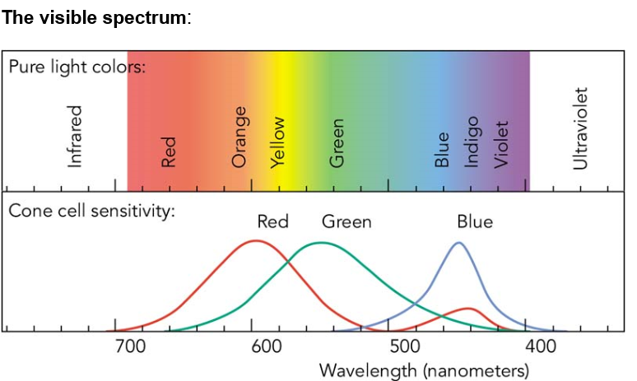

d) The astronaut returns to Earth and is looking through a telescope at the torch, which is still flying away one hour later. Explain **two** ways in which the photons from the torch will now look different from your answer to part b). **[2 marks]**

|  |
| --- |
|  |
|  |
|  |

e) Using the gravitational red shift formula shown on page 32, calculate the new frequency of a 9.00 x 1015 Hz photon originating at the surface of our sun. The new frequency is received/measured in empty space outside the sun’s gravitational field. **[4 marks]**

f) Would Edwin Hubble need to take gravitational red shift into account in formulating his theory of an expanding universe? Explain why or why not. **[2 marks]**

|  |
| --- |
|  |
|  |
|  |

g) A satellite orbiting the earth is set to receive signals at a frequency of 3.00 x 106 Hz. Should the signal be sent from the transmitter at the surface of the earth at a frequency above, equal to or below 3.00 x 106 Hz taking into account gravitational red shift? Do not calculate your answer. **[2 marks]**

|  |
| --- |
|  |
|  |
|  |

Extra page for additional working

|  |
| --- |
|  |

Extra page for additional working

|  |
| --- |
|  |

Extra page for additional working

Extra page for additional working

**END OF EXAMINATION**